Table of Content

Introduction 3

Main Features 3

Forming a Development Team 3

Preliminary Research 3

Brainstorming 3

Research – Web Market Analysis 3

Description 3

Technical Requirements 4

Personas 4

Use Cases 4

Activity Diagram 4

Entities (20 marks) 4

Content Plans (10 marks) 4

Prototypes (20 marks) 4

Class Diagram (20 marks) 5

Implementation - Developing the Agile Plan (20 marks) 5

Conclusion 5

Team Contributions 6

References 6

# Introduction

There are many obstacles in the way of creating a successful tech start-up, from putting together a competent team to locating the best resources and mentors. A recurrent bottleneck persists despite the rise of digital entrepreneurs: a dearth of easily available platforms that promote productive teamwork and deep connections.

A networking and collaboration tool created especially for tech start-ups is called Co-Lab Connect. To link founders with possible co-founders, team members, and mentors, the app uses AI-driven matchmaking. To facilitate smooth project management, it also offers a virtual collaboration area furnished with resources like task boards, video conferencing, and shared code repositories. With the help of its creative Skill swap feature, users may swap knowledge (for example, coding skills for design help), fostering a vibrant community of support and development.

In keeping with the goal of supporting high-tech start-ups, Co-Lab Connect empowers entrepreneurs to strengthen teams, encourage innovation, and expedite communication to address important pain issues. Start-ups will have access to resources through this platform that are necessary for expansion and sustainability in the cutthroat tech sector.

# Main Features

**Features of Co-Lab Connect**

1. **AI Matchmaking System**:
   * Advanced AI algorithms match users based on their profiles, skills, project needs, and goals.
   * Compatibility scores to help users find the best matches.
   * Filters for refining matches based on location, industry focus, and start-up stage.
2. **User Profiles**:
   * Comprehensive profiles showcasing skills, experience, roles (e.g., Founder, Developer, Mentor), and collaboration preferences.
   * Portfolio section for users to display past projects, achievements, and certifications.
3. **Skill Exchange System**:
   * Points-based barter system for trading expertise, such as coding, design, marketing, or business strategy.
   * Built-in transaction logs to track exchanges and ensure accountability.
   * Skill ratings and reviews to maintain quality standards.
4. **Virtual Workspaces**:
   * Dedicated collaboration spaces linked to projects.
   * Integrated task boards (e.g., Kanban boards) for tracking progress.
   * Real-time document sharing and editing.
   * Video conferencing integration for team meetings (e.g., via Zoom, Teams).
5. **Project Management Tools**:
   * Tools for creating, assigning, and tracking tasks within projects.
   * Milestone and deadline tracking to ensure timely delivery.
   * Repository links (e.g., GitHub) for version control and code sharing.
6. **Community Forums**:
   * Public and private forums for discussing ideas, sharing challenges, and seeking advice.
   * Categories for networking events, mentorship opportunities, and Q&A sessions.
   * Moderation features to ensure productive and respectful discussions.
7. **Mentorship Hub**:
   * Dedicated space for mentors to offer guidance and resources to start-ups.
   * Scheduling tools for booking mentorship sessions.
   * Progress tracking for mentee development.
8. **Event Management**:
   * Platform to organize and participate in virtual or in-person events.
   * Features for creating event pages, RSVP management, and hosting webinars.
9. **Notifications and Alerts**:
   * Real-time updates on new matches, project progress, and community activity.
   * Customizable alert preferences to focus on relevant notifications.
10. **Search and Discovery**:
    * Advanced search functionality to find users, projects, or resources based on specific criteria.
    * Tag-based system for easy navigation and resource discovery.
11. **Analytics Dashboard**:
    * Insights into user activity, project performance, and skill exchange transactions.
    * Visual reports to track collaboration metrics and outcomes.
12. **Data Security and Privacy**:
    * Secure login with multi-factor authentication.
    * Role-based access controls to safeguard sensitive project data.
    * Compliance with global data protection regulations (e.g., GDPR, CCPA).
13. **Future Expansion Features**:
    * Integration with funding platforms to connect start-ups with investors.
    * AI-driven learning recommendations for skills enhancement.
    * Global networking options to connect entrepreneurs across borders.

**Future Goals for Co-Lab Connect APP**

To further enhance the platform and cater to a wider audience, we envision the following future goals:

1. **Expanding the Platform's Reach Global Expansion**: Localize the platform for different regions and languages to attract a global user base.

* **Strategic Partnerships:** Collaborate with universities, tech companies, and industry organizations to expand our reach and offer exclusive benefits to members.

1. **Enhancing the User Experience Personalized Recommendations**: Utilize AI to provide tailored recommendations for projects, mentors, and learning resources.

* **Gamification**: Implement gamification elements to motivate user engagement and encourage participation.
* **Improved Search Functionality**: Enhance the search capabilities to help users find relevant information and connections.

1. **Specialized Communities Create Niche Communities**: Develop communities for specific technologies, industries, or interests (e.g., AI, blockchain, game development).

* **Host Virtual and In-Person Events**: Organize online workshops, webinars, and hackathons to foster learning and networking.

4. **Expand to Global Market**: Reach a wider audience by localizing the platform for different regions.

5**. Integrate AI Tools:** Utilize AI to enhance the user experience, such as intelligent chatbots and personalized recommendations.

6. **Corporate Partnerships**: Collaborate with companies to offer exclusive opportunities and resources.

**How Co-Lab Connect APP Relates to the Theme**

Co-Lab Connect directly aligns with the theme of fostering collaboration and innovation. By providing a platform for tech professionals to connect, share knowledge, and work together on projects, the app embodies the spirit of collaboration and innovation.

Here's a breakdown of how Co-Lab Connect fulfills the theme:

1.**Collaboration**: Peer-to-Peer Collaboration: Users can connect with like-minded individuals to form teams, share ideas, and work on joint projects.

**Mentorship and Guidance**: Experienced professionals can mentor aspiring individuals, fostering knowledge transfer and career growth. Community Building: The platform encourages a sense of community through forums, discussions, and virtual events, fostering a collaborative environment.

2. **Innovation:** Idea Sharing and Brainstorming: Users can share their innovative ideas and receive feedback from the community.

**Hackathons and Challenges**: The platform can host virtual and in-person hackathons to encourage innovation and problem-solving. Experimentation and Learning: Users can experiment with new technologies and learn from each other’s experiences.

1. **Fostering Creativity and Problem-Solving:**

**Hackathons and Challenges:** The platform can host virtual and in-person hackathons to encourage innovation and creativity.

**Brainstorming Sessions**: Users can collaborate on ideas and solutions to real-world problems.

**Experimentation:** The platform can provide a safe space for users to experiment with new technologies and approaches.

**Democratizing Innovation:** Open Access: By providing a free or low-cost platform, Co-Lab Connect empowers individuals from all backgrounds to participate in innovation. **Community-Driven Innovation**: The platform fosters a community-driven approach, where users can collaborate on projects, share ideas, and collectively solve problems.

1. **Accelerating Learning:**

**Peer-to-Peer Learning**: Users can learn from each other through mentorship, code reviews, and collaborative projects. Continuous Learning: The platform promotes lifelong learning by providing access to tutorials, workshops, and online courses. Skill Sharing: Users can share their expertise and learn new skills through the skill-sharing marketplace. By facilitating these aspects, Co-Lab Connect empowers individuals to reach.

**Revenue Generation Strategies for Co-Lab Connect**

1. **Premium Subscriptions**: Offer premium features like advanced matching algorithms, priority support, exclusive content, and ad-free experience. Tiered pricing models to cater to different user needs.

2. **Skill Marketplace Fees**: Charge a commission on transactions made through the skill exchange marketplace. Implement a fee-based model for premium listings or featured profiles.

3. **Sponsored Content and Partnerships**: Collaborate with tech companies to offer sponsored content, workshops, and webinars. Partner with recruitment agencies to offer job placement services.

4. **Event Ticketing**: Charge fees for attending virtual or in-person events organized by the platform.

5. **Data Insights and Analytics**: Provide valuable insights and analytics to businesses and organizations. Offer customized reports and data visualizations.

6. **Freelance Marketplace**: Facilitate freelance work by connecting freelancers with clients and charging a commission on project fees.

7. **E-commerce**: Sell merchandise like branded apparel, tech accessories, and books. Partner with online retailers to offer exclusive deals and discounts to Co-Lab Connect members.

8. **Affiliate Marketing**: Partner with relevant companies to promote their products and services and earn commissions.

9. **Consulting Services**: Offer consulting services to businesses and individuals on topics like digital transformation, innovation, and team building.

10**. Data Licensing**: Anonymize and aggregate user data to generate valuable insights for research and development. License this data to third-party organizations for specific purposes. By carefully implementing these strategies, Co-Lab Connect can generate sustainable revenue while continuing to provide value to its user.

# Forming a Development Team

Development Team

Stated below are the names, roles and skill required for this project

|  |  |  |
| --- | --- | --- |
| Name | Role | Skills |
| Chiagozie Maduemesi | Product Owner | Business strategy, stakeholder communication |
| Faith Okunola | Content Strategist and researcher | Market analysis, persona creation, content writing |
| Onolemen Omokhuale | UI/UX Designer | Figma, prototyping, user research |
| Shresta Rapol | Back End Developer | Database design, server-side development |
| David Carter | Full Stack Developer | Node.js, React.js, MongoDB, API development |
| Mese Lee | Q/A Engineer | Testing frameworks, front-end coding, documentation |
| Oneal Williams | Scrum Master | Agile processes, team facilitation |

The Development team is presented below

|  |  |  |
| --- | --- | --- |
| Role | Team Members | Task |
| Product Owner | Chiagozie Maduemesi | - Represents the customer and stakeholder interests |
|  |  | - Prioritizes features and manages the product backlog. |
|  |  | - Defines the vision and goals for Co-Lab Connect. |
| Scrum Master | Oneal Williams | - Facilitates sprint planning, reviews and retrospectives and ensures the team follows agile principle. |
| Brainstorming | Onolemen Omokhuale, Shresta Rapol, Faith Okunola, David Carter. | - Generating ideas for user experience and technical implementation |
| Research | Faith Okunola, Omokhuale Onolemen | -Findings on already existent platforms and collaboration tools, skill exchange platform, AI algorithm. |
| Business Model | Chiagozie Maduemesi, Faith Okunola | Creating sustainable business strategy aligning with the startup goals as well as defining revenue streams. |
| Market Analysis and Personas | Faith Okunola, Omokhuale Onolemen | -Developing personas for target audience and also analyzing market needs. |
| UseCases | Mese Lee, Shresta Rapol | - Defining user interactions with match making and collaboration tools. |
|  |  | -Creation of flowcharts for document use. |
| Entity Relationship Diagram | Shresta Rapol, David Carter | -Design the database schema users, connections, task and skill exchanging. |
|  |  | -Ensuring scalability for future growth. |
| Class Diagram | Shresta Rapol, Mese Lee | -Mapping key features like match making, tasks, and repositories to class relationships. |
|  |  | -Designing the system object-oriented architecture. |
| Content Plans | Omokhuale Onolemen, Mese Lee | -Creation of content for the platform, including landing page, user profiles and features description. |
|  |  | -Writing community guidelines and onboarding |
| Prototype Mockups | Omokhuale Onolemen, Mese Lee | -Figma designs |
|  |  | -Creative interactive prototypes to demonstrate navigation and features. |
| Code Development | Shresta Rapol, David Carter, Mese Lee | -Develop front-end and back-end. |
|  |  | -Integration of APIs for AI matchmaking and conferencing. |
| Testing | Mese Lee, Oneal Williams | -Unit, integration and regression testing |
|  |  | -Usability testing and feedback. |
| Documentation | Oneal Williams, Mese Lee | -Writing user manuals and onboarding guidelines. |
|  |  | -Create technical documentation for the system (API references, database schema) |

# Preliminary Research

# Brainstorming

**Goals and Benefits**

1. **Enhanced Networking**:
   * **AI-Powered Matchmaking**: Match users based on their skills, goals, and project needs.
   * Filters to find collaborators by location, industry focus, or development stage.
2. **Efficient Collaboration**:
   * **Integrated Workspace**: Tools for task management (e.g., Kanban boards), video conferencing, and GitHub repositories.
   * Shared document editing and real-time collaboration features.
3. **Skill Exchange**:
   * A points-based system to exchange services, promoting a barter-like ecosystem.
   * For example, a developer can exchange coding services for marketing expertise.
4. **Start-Up Empowerment**:
   * Access to curated resources, such as funding opportunities, business templates, and industry best practices.
   * Build long-term partnerships with aligned professionals and organizations.

**Key Features**

* **User Profiles**: Detailed profiles showcasing skills, projects, and collaboration preferences.
* **AI Matchmaking Algorithm**: Automated and manual search options to find ideal matches.
* **Virtual Workspaces**: Dedicated spaces with video conferencing links, shared repositories, and task boards.
* **Community Forums**: Networking events, Q&A sessions, and discussion boards for peer-to-peer support.

**Competitive Differentiation**

While platforms like LinkedIn offer networking opportunities, Co-Lab Connects tailored focus on the tech start-up ecosystem and its integrated tools for collaboration and skill exchange make it uniquely positioned to solve start-ups’ specific challenges.

# Research – Web Market Analysis

Research: Web Market Analysis for Co-Lab Connect APP

Existing Similar Applications and Their Features

While there are numerous platforms that cater to specific aspects of technical collaboration and

community building, a comprehensive platform like Co-Lab Connect that seamlessly integrates various

features are still relatively rare.

Here are some existing platforms that share some similarities with Co-Lab Connect:

1. **GitHub:**

**Core Features:** Version control, code hosting, and collaboration tools.

**Relevance to Co-Lab Connect:** GitHub provides a strong foundation for collaborative coding and

project management, but lacks the broader community and mentorship aspects that Co-Lab

Connect offers.

2. **Stack Overflow:**

**Core Features:** Q&A platform for programmers.

**Relevance to Co-Lab Connect:** While Stack Overflow is a valuable resource for technical questions,

it doesn't provide the same level of community and collaboration features as Co-Lab Connect.

3. **Slack:**

**Core Features**: Real-time communication and collaboration tool.

**Relevance to Co-Lab Connect**: Slack is excellent for team communication, but it lacks the broader community and mentorship aspects of Co-Lab Connect.

1. **LinkedIn**: Core Features: Professional networking platform. Relevance to Co-Lab Connect: LinkedIn is a great platform for networking, but it doesn't offer the same level of technical collaboration and community building as Co-Lab Connect.

**Why Develop Co-Lab Connect APP?**

* **Unmet Need**: While there are many tools for specific aspects of tech collaboration, there's a need for a comprehensive platform that integrates various features into a seamless user experience.
* **Fostering Innovation:** By connecting diverse individuals and fostering collaboration, Co-Lab Connect can drive innovation and accelerate the development of new technologies.
* **Empowering Individuals**: The platform empowers individuals to learn, grow, and achieve their career goals.
* **Creating a Strong Tech Community**: By building a strong and supportive community, Co-Lab Connect can help to address the challenges faced by tech professionals. By addressing these needs and leveraging its unique features, Co-Lab Connect can become a valuable tool for tech professionals worldwide.

**Comparison of Similar Apps to Co-Lab Connect APP**

# Description

Co-Lab Connect is a dynamic online platform designed to foster collaboration and innovation among tech professionals. It's a space where you can connect with like-minded individuals, share knowledge, and work on exciting projects. Whether you're a seasoned developer, a budding entrepreneur, or a student exploring the world of technology, Co-Lab Connect offers something for everyone. Our platform provides a range of features to provide support to everyone. Co-Lab Connect is more than just a platform; it's a thriving community of tech enthusiasts, entrepreneurs, and professionals. Designed to foster collaboration, innovation, and personal growth, our platform provides a space for you to connect, learn, and achieve your goals.

**Benefits of Co-Lab Connect APP**

1. **Facilitated Networking**: AI-powered matching system to connect users with compatible partners. Virtual networking events and workshops. Dedicated forums and chat rooms for discussions and collaboration.

2. **Skill Sharing and Knowledge Transfer:** A marketplace for users to offer and acquire skills. Mentorship programs with experienced professionals. Collaborative projects to foster teamwork and learning.

3. **Community Building**: A supportive community of like-minded individuals. Regular events and meetups to foster connections. Shared resources and tools to enhance collaboration.

4. **Career Advancement:** Job boards and career counselling services. Opportunities to showcase skills and build a professional portfolio. Access to industry experts and recruiters.

5. **Personal Growth Build Confidence:** Gain confidence in your abilities through collaborative projects and mentorship. Develop Soft Skills: Improve your communication, teamwork, and leadership skills. Foster Creativity: Explore new ideas and approaches to problem-solving.

6**. Collaborative Projects Team Up on Innovative Projects:** Collaborate with others on exciting projects and build your portfolio. Share Resources and Knowledge: Contribute to open-source projects and knowledge bases. Crowd-source Solutions: Leverage the collective intelligence of the community to solve complex problems.

7. **Accelerated Learning Access to Expert Mentorship**: Connect with experienced professionals who can provide guidance and support. Self-Paced Learning: Explore a vast library of tutorials, courses, and resources. Collaborative Learning: Work with peers on projects and learn from each other

# Technical Requirements

1.**Special Device Hardware Features:**

* **High-Speed Internet Connection**: Essential for real-time collaboration, video conferencing, and file sharing.
* **Powerful Processor:** Required for handling complex computations, AI-powered matching

algorithms, and real-time video processing.

* **Sufficient RAM**: To ensure smooth performance and prevent lag during video calls, file sharing, and

other resource-intensive activities.

* **Secure Servers:** Robust servers to protect user data and ensure the platform's reliability and security.

2. **Special Input Controls:**

* **Intuitive User Interface**: A user-friendly interface with clear navigation and easy-to-use controls.
* **Real-Time Chat and Video Conferencing**: Integration with reliable video conferencing and

messaging solutions.

* **File Sharing and Collaboration Tools:** Seamless integration with cloud storage and version control

systems.

* **AI-Powered Interactions**: Natural language processing and machine learning for intelligent search,

recommendations, and automated tasks.

3. **Contextual Constraints and Advantages**

* **Remote Collaboration:** The app needs to be designed to facilitate seamless collaboration between

users located in different time zones and geographical locations.

* **Diverse User Base:** The app should be accessible to users with varying levels of technical expertise,

from beginners to experienced professionals.

* **Security and Privacy:** Robust security measures must be implemented to protect user data and

prevent unauthorized access.

* **Scalability:** The app should be able to handle a growing user base and increasing traffic.

Cross-Platform Compatibility: The app should be accessible on various devices and operating

systems (web, mobile, desktop).

By considering these technical requirements, Co-Lab Connect can provide a seamless and efficient user experience, fostering collaboration and innovation among tech professionals.

Personas

# Use Cases

Use Case Description:

|  |  |
| --- | --- |
| **Use Case Name** | **Description** |
| Register/create Profile | Allows users to register on the platform and create a detailed profile, including their skills, goals, and preferences to help match them with others. |
| Provide Mentorship | Enables users to offer their expertise to others by setting up a profile as a mentor, listing their skills and areas of mentorship. |
| Search for Mentors | Users can search for available mentors based on skills, goals, and other preferences to find the right person to guide them. |
| AI Matching/AI_search | The system uses AI to match users with co-founders, mentors, or collaborators based on their profiles, skills, and goals. |
| Connect with Potential Team Members | Allows users to connect with potential team members after matching, sending collaboration requests that can be accepted or declined. |
| Initiate a Video conference | Users can initiate video calls to discuss projects or collaborate in real-time, facilitating communication regardless of location. |
| Manage Task Board | Users can create and manage task boards for their projects, assigning tasks to collaborators and tracking progress |
| Create Virtual Collaboration Space | Users can create a virtual space to collaborate on projects, including tools like document sharing, code repositories, and task management. |
| Offer Skill Exchange | Users can offer their skills to others in exchange for services (e.g., coding for design), promoting skill-sharing within the platform. |
| Request Skill Exchange | Users can request skill exchanges with others based on their needs, browsing available offers and proposing exchanges. |

# Activity Diagram

# Entities (20 marks)

# Content Plans (10 marks)

#### **Content Details**:

* **Loading Screen**:
  + App logo: "Co-Lab Connect."
  + Tagline: "Empowering Tech Entrepreneurs."
* **Onboarding Steps**:
  + **Screen 1**: "Let's Get Started" (Introduction to the app).
    - Description: "Connect with co-founders, mentors, and collaborators effortlessly."
    - CTA: "Next."
  + **Screen 2**: Collect user details:
    - Name, date of birth, skills, areas of expertise, start-up goals.
  + **Screen 3**: Upload profile picture.
    - Instruction: "Upload a professional profile picture to stand out."

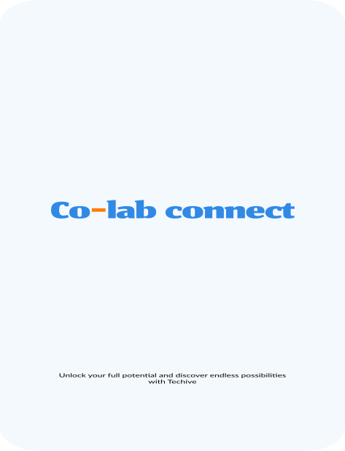 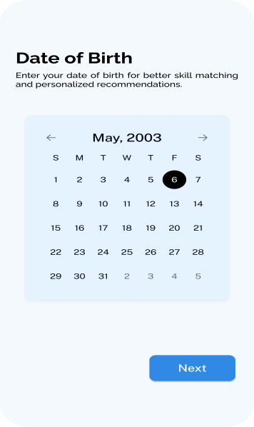 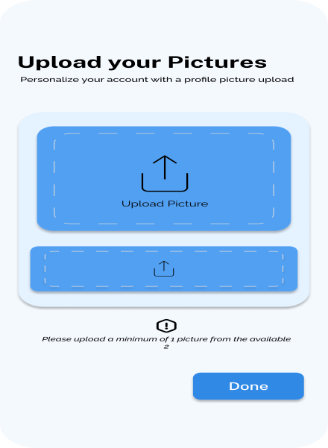

### **2. Create Account Screen**

**Purpose**: Allow new users to create an account.

#### **Content Details**:

* Fields:
  + Full Name.
  + Email Address.
  + Password.
  + Confirmation Password.
* CTA:
  + "Create Account" (Submit button).
  + "Already have an account? Log In."

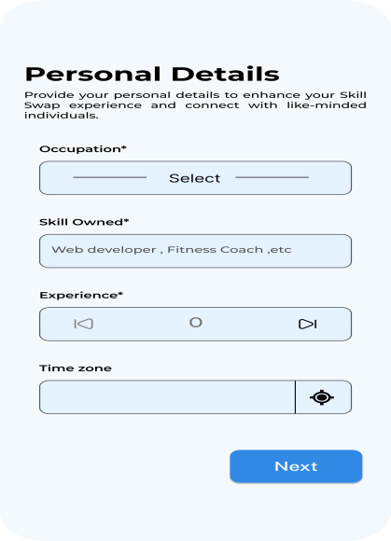 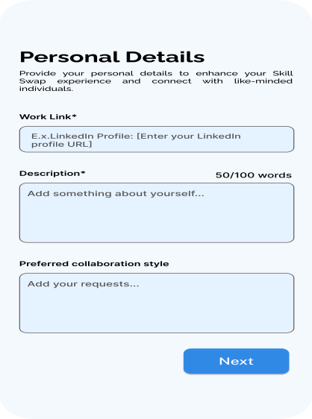

### **3. Home Screen**

**Purpose**: Provide a personalized dashboard with quick access to features.

#### **Content Details**:

* **Welcome Banner**:
  + Greeting: "Welcome back, [User's Name]!"
  + Suggested actions: "Find collaborators, start a project, or join the community."
* **Sections**:
  + Featured Posts: Display trending discussions or articles.
  + Navigation Tabs: Home, Matchmaking, Community, Chat.
* **CTA Buttons**:
  + "Find Collaborators."
  + "Explore Projects."

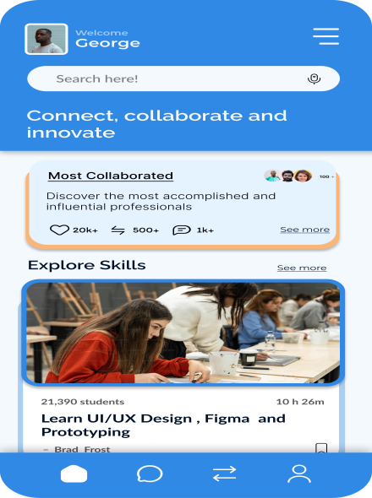 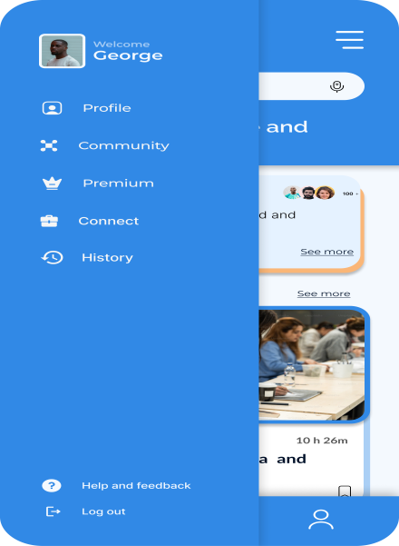

### **4. Matchmaking Screens**

**Purpose**: Facilitate AI-driven connections based on user preferences.

#### **Content Details**:

* **Matchmaking Search Screen**:
  + Filters:
    - Role: Co-founder, Mentor, Team Member.
    - Skills: Dropdown or tags for specific expertise.
    - Location: Remote, in-person, hybrid.
  + CTA: "Start Matching."
* **Matching Results**:
  + Profile cards:
    - Name, profile picture, skills, brief bio.
    - CTA: "View Profile" or "Send Request."

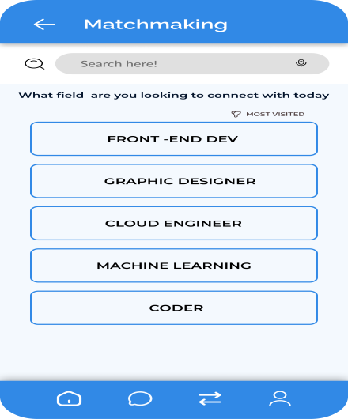 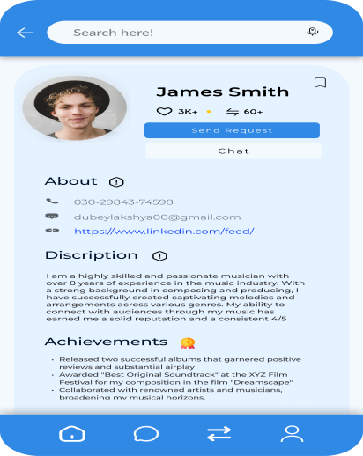

### **5. Community Screens**

**Purpose**: Enable user interaction through forums, Q&A, and discussions.

#### **Content Details**:

* **Community Dashboard**:
  + Categories:
    - Start-up advice, Fundraising tips, Product development.
  + Trending topics:
    - "Best practices for pitching to investors."
    - "How to build an MVP quickly."
* **Post Details Screen**:
  + Content:
    - Title, author, post content, and date.
    - Comments section: User comments with likes/replies.
  + CTA:
    - "Reply" or "Add Comment."

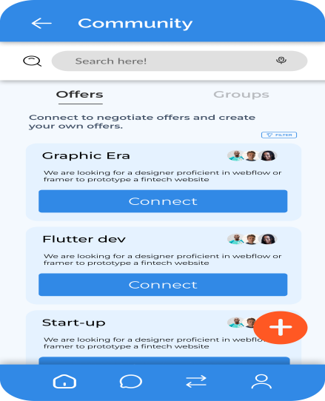 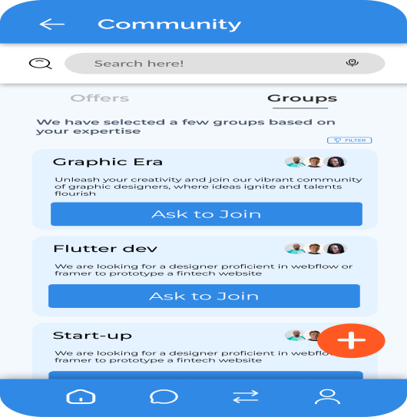

### **6. Chat Screens**

**Purpose**: Allow direct communication between users.

#### **Content Details**:

* **Chat List Screen**:
  + Display recent conversations:
    - Profile picture, name, last message, and timestamp.
  + CTA: "Start New Chat."
* **Individual Chat Screen**:
  + User messages with timestamps.
  + Input box:
    - "Type your message here…"
    - Send button (icon).

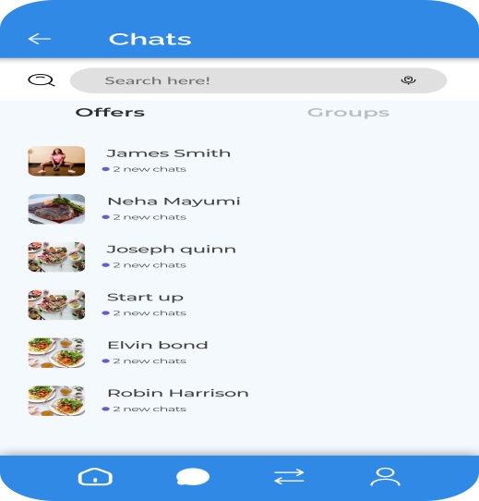 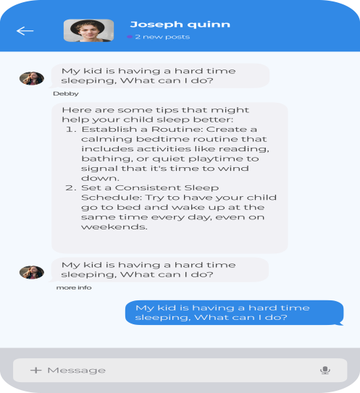

### **7. User Profile**

**Purpose**: Showcase user skills, goals, and availability.

#### **Content Details**:

* **Profile Sections**:
  + Basic Info: Name, bio, location.
  + Skills: Tags for technical and soft skills.
  + Current Goals: Example: "Looking for a full-stack developer."
  + Portfolio:
    - Links to GitHub, LinkedIn, or personal websites.

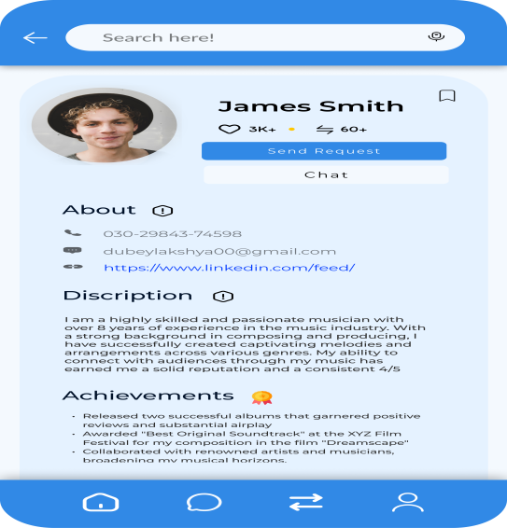

### **8. Skill Exchange Screen**

**Purpose**: Allow users to trade expertise with others.

#### **Content Details**:

* **Skill Listings**:
  + Example: "Offering coding mentorship in exchange for design expertise."
* **Post a Listing**:
  + Form fields:
    - Offered skills, Needed skills, Time commitment.
  + CTA: "Post Listing."

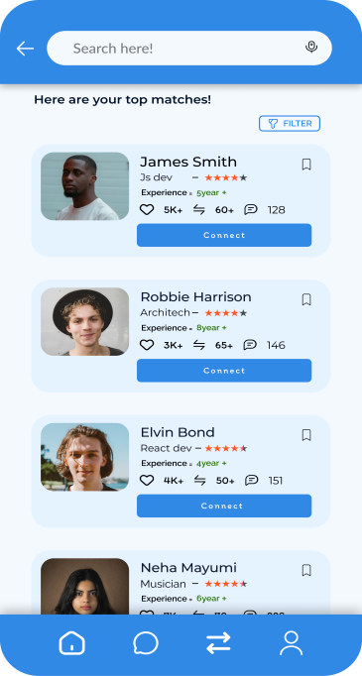 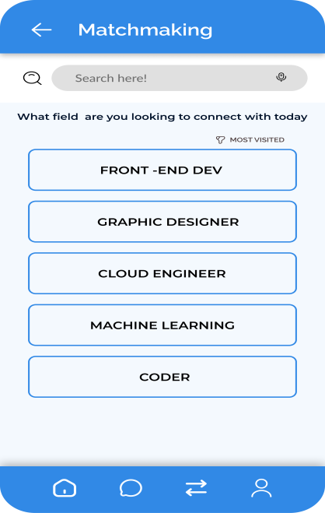

### **9. Navigation Footer**

**Purpose**: Provide quick access to core features.

#### **Tabs**:

1. **Home**.
2. **Matchmaking**.
3. **Community**.
4. **Chat**.
5. **Profile**.

# Prototypes (20 marks)

Kindly click on this link to access the Figma design “[Figma](https://www.figma.com/design/Xj2jtPWH2KdARyMjpox4UB/Untitled?node-id=208-2700&node-type=frame&t=INZ6isGRFuIrphgy-0)”.

Kindly click on this link to access the Prototype design “[Prototype](https://www.figma.com/proto/Xj2jtPWH2KdARyMjpox4UB/Untitled?page-id=0%3A1&node-id=206-2327&node-type=frame&t=INZ6isGRFuIrphgy-0&scaling=scale-down&content-scaling=fixed&starting-point-node-id=205%3A861&show-proto-sidebar=1)”

# Class Diagram (20 marks)

# Implementation - Developing the Agile Plan (20 marks)

# Conclusion

In conclusion, Co-Lab Connect provides a ground-breaking answer to one of the biggest problems that tech entrepreneurs are currently facing: efficient networking and cooperation. This platform enables start-ups to develop better teams and achieve sustainable growth by combining AI matchmaking, powerful project management tools, and a dynamic skill exchange system.  
  
The platform may be expanded in the future to include:  
sophisticated analytics to monitor individual contributions and project success.  
collaborations with academic institutions to offer certification and training courses.  
Improved funding prospects thanks to characteristics that match investors.

Co-Lab Connect essentially creates an end-to-end ecosystem that is customized to meet the specific requirements of tech entrepreneurs, going beyond conventional networking platforms. It not only fits with the idea of helping high-tech startups, but it also offers a basis for creativity and cooperation in the larger corporate environment.

# Team Contributions

|  |  |
| --- | --- |
| **Team Members** | **Content covered** |
| Chiagozie, Maduemesi | Introduction, Brainstorming, Features and Conclusion |
| Faith, Okunola | Personas, Descriptions, Web Analysis, Technical Requirement |
| Onolemen, Omokhuale | Forming Development Team, Content plans and prototype. |
| Shresta, Rapol | use cases , ER diagram, Activity diagram, class diagram, Developing Agile Plan excel sheet |

# References